**Summary:** Information on all current [VA.gov](http://va.gov/) surveys. [To find more background information on VA.gov Surveys, review the product outline.](https://vfs.atlassian.net/wiki/spaces/Contact/pages/1794015358)

### **Account access**

OCTO Lead: Chante Lantos-Swett

Product Manager: Anita Middleton

Vsignals Contact: Brian Brown

## **Available surveys**

### **Satisfaction/Intercept survey**

This is the main [VA.gov](http://va.gov/) survey that collects general website satisfaction and trust feedback.

**Excludes:**

* [http://myhealth.va.gov](http://myhealth.va.gov/)
* [ebenefits.va.gov](http://ebenefits.va.gov/)

**Targeting parameters:**

* Loyalty factor of 60 second or longer session
* 5% of users who hit the loyalty factor
* Based on sessions, not users
* Pop up window
* If a user declines an invitation, does not intercept for 90 days
* If a user submits a form, does not intercept for 90 days

**Content:**

*4 questions*

1. Please rate your experience with [VA.gov](http://va.gov/) today.
   1. Very bad
   2. Somewhat bad
   3. Neither bad nor good
   4. Somewhat good
   5. Very good
2. Why did you select that rating? (Open text box)
3. How did this interaction change your trust in Veterans Affairs?
   1. Decreased my trust
   2. Somewhat decreased my trust
   3. Neither increased nor decreased my trust
   4. Somewhat increased my trust
   5. Increased my trust
4. How much do you trust Veterans Affairs to fulfill our country’s commitment to Veterans?
   1. High level of distrust
   2. Modest level of distrust
   3. Neither trust or distrust
   4. Modest level of trust
   5. High level of trust

### **Footer Feedback Survey**

This the the survey that is used to collect user feedback for specific Veteran Facing Services.

**Targeting parameters:**

* Floating feedback button on the right hand side of specific URLs
* Lightbox element

**Content:**

*3 Questions*

1. Were you able to do your task today?
   1. Yes
   2. No
2. What task were you trying to do today?
   1. [Free text]
3. What is your overall satisfaction with this site?
   1. 1 = Very dissatisfied
   2. 5 = Very satisfied

**What is looks like:**

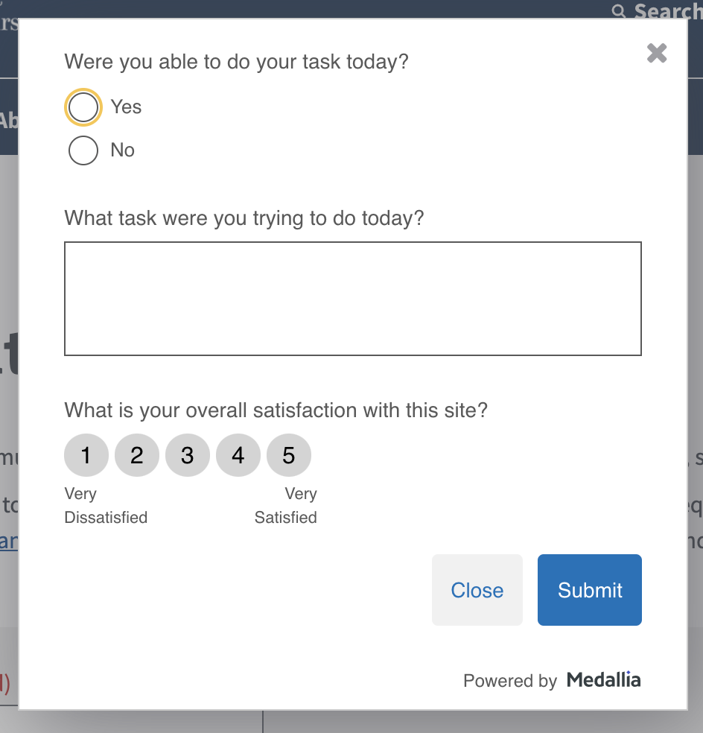

**Where to see it live:**

Right [here](https://www.va.gov/find-locations) on our [VA.gov](http://va.gov/) Find Locations page(s).

**How to add:**

To learn more about how to implement a digital survey for your [VA.gov](http://va.gov/) tool or pages, review the [“How to request a VA.gov digital survey” page.](https://vfs.atlassian.net/wiki/spaces/Contact/pages/1793556578)

### **Additional Resources**

* [How to request a survey](https://github.com/department-of-veterans-affairs/va.gov-team/blob/master/platform/analytics/medallia-request-survey.md)
* [Product Outline](https://github.com/department-of-veterans-affairs/va.gov-team/blob/master/teams/vsp/teams/contact-center/product-outlines/medallia-product-outline.md)
* [Release Notes](https://github.com/department-of-veterans-affairs/va.gov-team/blob/master/products/platform/medallia/medallia-release-notes.md)
* [Rollout](https://github.com/department-of-veterans-affairs/va.gov-team/issues/17925)